**What is Computer Vision?**

Computer vision is a field of study which enables computers to replicate the human visual system. It’s a subset of [artificial intelligence](https://www.mygreatlearning.com/blog/what-is-artificial-intelligence/) which collects information from digital images or videos and processes them to define the attributes. The entire process involves image acquiring, screening, analysing, identifying and extracting information. This extensive processing helps computers to understand any visual content and act on it accordingly. You can also take up a [computer vision course](https://www.mygreatlearning.com/academy/learn-for-free/courses/introduction-to-computer-vision) for free to understand the basics under Artificial intelligence domain.  
Computer vision projects translate digital visual content into explicit descriptions to gather multi-dimensional data. This data is then turned into computer-readable language to aid the decision-making process. The main objective of this branch of [artificial intelligence](https://www.mygreatlearning.com/blog/top-10-hot-artificial-intelligence-technologies/) is to teach machines to collect information from pixels.

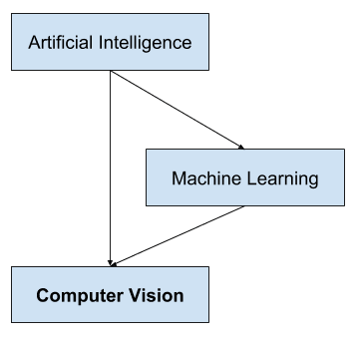

**Computer Vision and Image Processing**

Computer vision is distinct from image processing.

[Image processing](https://en.wikipedia.org/wiki/Digital_image_processing) is the process of creating a new image from an existing image, typically simplifying, or enhancing the content in some way. It is a type of digital signal processing and is not concerned with understanding the content of an image.

A given computer vision system may require image processing to be applied to raw input, e.g., pre-processing images. Examples of image processing include:

* Normalizing photometric properties of the image, such as brightness or color.
* Cropping the bounds of the image, such as centering an object in a photograph.
* Removing digital noise from an image, such as digital artifacts from low light levels.

**Computer Vision Applications**

* Optical character recognition (OCR)
* Machine inspection
* Retail (e.g. automated checkouts)
* 3D model building (photogrammetry)
* Medical imaging
* Automotive safety
* Match move (e.g. merging CGI with live actors in movies)
* Motion capture (mocap)
* Surveillance
* Fingerprint recognition and biometrics

**What is Amazon Rekognition?**

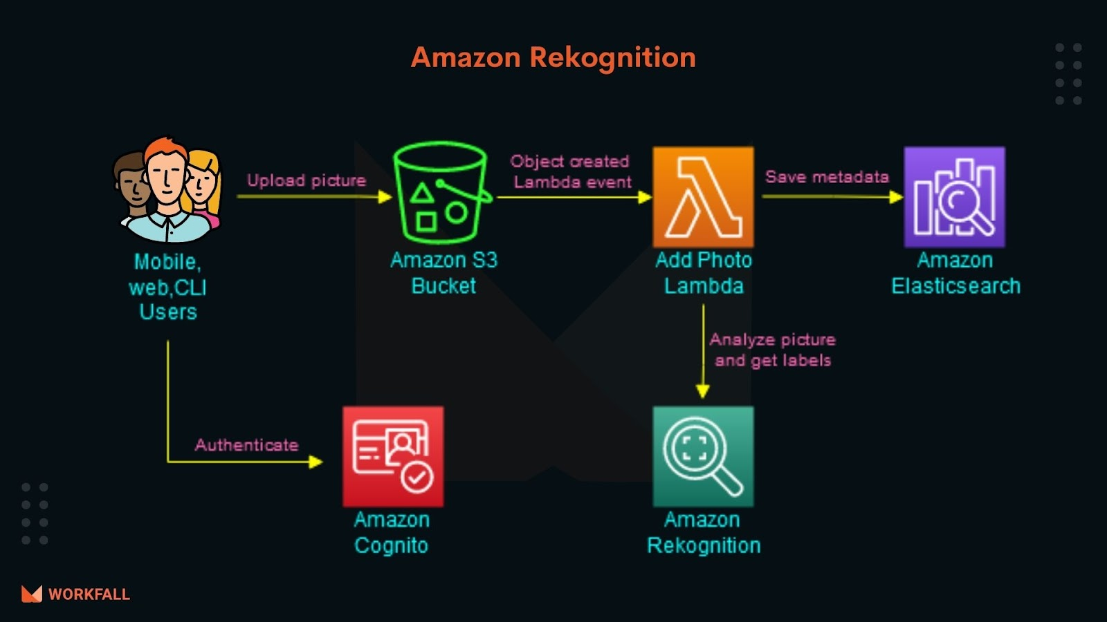

Amazon Rekognition, lets you identify objects, people, text, scenes, and activities in images and videos, as well as detect any inappropriate content. Amazon Rekognition also provides highly accurate facial analysis and facial search capabilities that you can use to detect, analyze, and compare faces for a wide variety of user verification, people counting, and public safety use cases.

**Amazon Rekognition**

Amazon Rekognition makes it easy to add image and video analysis to your applications. You just provide an image or video to the Amazon Rekognition API, and the service can identify objects, people, text, scenes, and activities. It can detect any inappropriate content as well. Amazon Rekognition also provides highly accurate facial analysis, face comparison, and face search capabilities. You can detect, analyze, and compare faces for a wide variety of use cases, including user verification, cataloging, people counting, and public safety.

Amazon Rekognition is based on the same proven, highly scalable, deep learning technology developed by Amazon’s computer vision scientists to analyze billions of images and videos daily. It requires no machine learning expertise to use. Amazon Rekognition includes a simple, easy-to-use API that can quickly analyze any image or video file that’s stored in Amazon S3. Amazon Rekognition is always learning from new data, and we’re continually adding new labels and facial comparison features to the service.

Common use cases for using Amazon Rekognition include the following:

* **Searchable image and video libraries** – Amazon Rekognition makes images and stored videos searchable so you can discover objects and scenes that appear within them.
* **Face-based user verification** – Amazon Rekognition enables your applications to confirm user identities by comparing their live image with a reference image.

* **Detection of Personal Protective Equipment**

Amazon Rekognition detects Personal Protective Equipment (PPE) such as face covers, head covers, and hand covers on persons in images. You can use PPE detection where safety is the highest priority. For example, industries such as construction, manufacturing, healthcare, food processing, logistics, and retail. With PPE detection, you can automatically detect if a person is wearing a specific type of PPE. You can use the detection results to send a notification or to identify places where safety warnings or training practices can be improved.

* **Sentiment and demographic analysis** – Amazon Rekognition interprets emotional expressions such as happy, sad, or surprise, and demographic information such as gender from facial images. Amazon Rekognition can analyze images, and send the emotion and demographic attributes to Amazon Redshift for periodic reporting on trends such as in store locations and similar scenarios. Note that a prediction of an emotional expression is based on the physical appearance of a person's face only. It is not indicative of a person’s internal emotional state, and Rekognition should not be used to make such a determination.

* **Facial Search** – With Amazon Rekognition, you can search images, stored videos, and streaming videos for faces that match those stored in a container known as a face collection. A face collection is an index of faces that you own and manage. Searching for people based on their faces requires two major steps in Amazon Rekognition:
  1. Index the faces.
  2. Search the faces.

* **Unsafe content detection** – Amazon Rekognition can detect adult and violent content in images and in stored videos. Developers can use the returned metadata to filter inappropriate content based on their business needs. Beyond flagging an image based on the presence of unsafe content, the API also returns a hierarchical list of labels with confidence scores. These labels indicate specific categories of unsafe content, which enables granular filtering and management of large volumes of user-generated content (UGC). Examples include social and dating sites, photo sharing platforms, blogs and forums, apps for children, ecommerce sites, entertainment, and online advertising services.

* **Celebrity recognition** – Amazon Rekognition can recognize celebrities within supplied images and in videos. Amazon Rekognition can recognize thousands of celebrities across a number of categories, such as politics, sports, business, entertainment, and media.

* **Text detection** – Amazon Rekognition Text in Image enables you to recognize and extract textual content from images. Text in Image supports most fonts, including highly stylized ones. It detects text and numbers in different orientations, such as those commonly found in banners and posters. In image sharing and social media applications, you can use it to enable visual search based on an index of images that contain the same keywords. In media and entertainment applications, you can catalog videos based on relevant text on screen, such as ads, news, sport scores, and captions. Finally, in public safety applications, you can identify vehicles based on license plate numbers from images taken by street cameras.

* **Custom labels**– With Amazon Rekognition Custom Labels, you can identify the objects and scenes in images that are specific to your business needs. For example, you can find your logo in social media posts, identify your products on store shelves, classify machine parts in an assembly line, distinguish healthy and infected plants, or detect animated characters in videos.
* **Integrating powerful image and video analysis into your apps** – You don’t need computer vision or deep learning expertise to take advantage of the reliable image and video analysis in Amazon Rekognition. With the API, you can build image and video analysis into any web, mobile, or connected device application.

* **Deep learning-based image and video analysis** – Amazon Rekognition uses deep-learning technology to accurately analyze images, find and compare faces in images, and detect objects and scenes within your images and videos. You can analyze images for the presence of many different labels and then filter the results to include and/or exclude sets of labels or label categories.

* **Scalable image analysis** – Amazon Rekognition enables you to analyze millions of images so you can curate and organize massive amounts of visual data.

* **Analyze and filter images based on image properties** – Amazon Rekognition lets you analyze image properties like quality or colors. You can determine the sharpness, brightness, and contrast of images. You can also detect dominant colors in the entire image, foreground, background, and objects with bounding boxes.

* **Integration with other AWS services** – Amazon Rekognition is designed to work seamlessly with other AWS services like Amazon S3 and AWS Lambda. You can call the Amazon Rekognition API directly from Lambda in response to Amazon S3 events. Because Amazon S3 and Lambda scale automatically in response to your application’s demand, you can build scalable, affordable, and reliable image analysis applications. For example, each time a person arrives at your residence, your door camera can upload a photo of the visitor to Amazon S3. This triggers a Lambda function that uses Amazon Rekognition API operations to identify your guest. You can run analysis directly on images that are stored in Amazon S3 without having to load or move the data. Support for AWS Identity and Access Management (IAM) makes it easy to securely control access to Amazon Rekognition API operations. Using IAM, you can create and manage AWS users and groups to grant the appropriate access to your developers and end users.

* **Low cost** – With Amazon Rekognition, you pay for the images and videos that you analyze, and the face metadata that you store. There are no minimum fees or upfront commitments. You can get started for free, and save more as you grow with the Amazon Rekognition tiered pricing model.

**How Amazon Rekognition works**

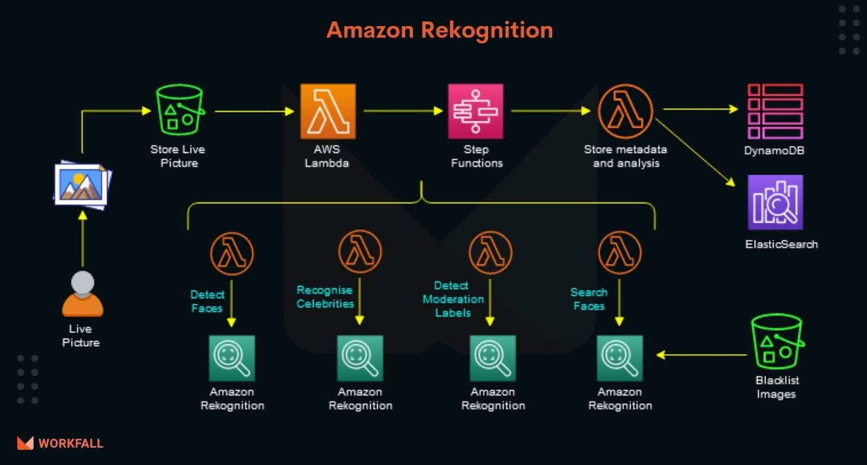

Amazon Rekognition provides two API sets. You use Amazon Rekognition Image for analyzing images, and Amazon Rekognition Video for analyzing videos.

Both APIs analyze images and videos to provide insights you can use in your applications. For example, you could use Amazon Rekognition Image to enhance the customer experience for a photo management application. When a customer uploads a photo, your application can use Amazon Rekognition Image to detect real-world objects or faces in the image. After your application stores the information returned from Amazon Rekognition Image, the user could then query their photo collection for photos with a specific object or face. Deeper querying is possible. For example, the user could query for faces that are smiling or query for faces that are a certain age.

You can use Amazon Rekognition Video to track the path of people in a stored video. Alternatively, you can use Amazon Rekognition Video to search a streaming video for persons whose facial descriptions match facial descriptions already stored by Amazon Rekognition.

The Amazon Rekognition API makes deep learning image analysis easy to use. For example, [RecognizeCelebrities](https://docs.aws.amazon.com/rekognition/latest/APIReference/API_RecognizeCelebrities.html) returns information for up to 100 celebrities detected in an image. This includes information about where celebrity faces are detected on the image and where to get further information about the celebrity.

The following information covers the types of analysis that Amazon Rekognition provides and an overview of Amazon Rekognition Image and Amazon Rekognition Video operations. Also covered is the difference between non-storage and storage operations.

Amazon Rekognition Image can be used to detect real-world objects or faces in the image. After your application stores, the information returned from Amazon Rekognition Image, the user could then query their photo collection for photos with a specific object or face.

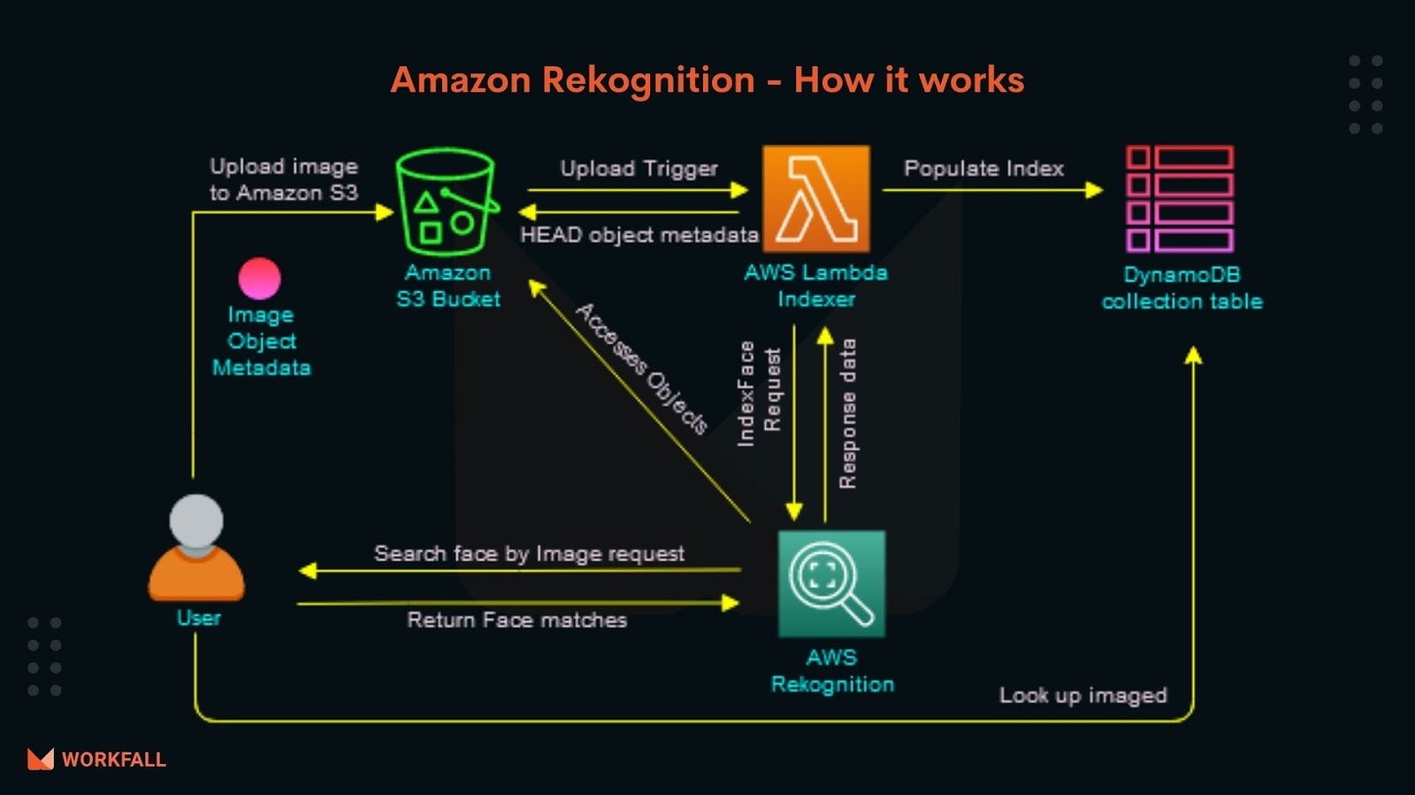

Amazon Rekognition Video will track the path of people in a stored video. Alternatively, you can use Amazon Rekognition Video to search a streaming video for persons whose facial descriptions match the facial descriptions already stored by Amazon Rekognition.

**Features of Amazon Rekognition**

**Text Detection –**Amazon Rekognition can read skewed and distorted text in photos and videos to capture information like store names, forced narratives overlaid on media, street signs, and text on product packaging.

**Face search and verification** – Experience face search, allowing you to identify a person in a photo or video with accuracy and agility using your private repository of face images. Also, verify identity by analyzing a face image against images you have stored for comparison.

**Celebrity Recognition** – Identify popular personalities from video and image libraries to catalog footage and photos

**PPE Detection** – Amazon Rekognition, allows you to analyze images from your on-premises cameras at scale to automatically detect if persons in images are wearing Personal Protective Equipment (PPE) such as face covers (face masks), hand covers (gloves), and head covers (helmets) and whether the protective equipment covers the corresponding body part (nose for face covers, head for head covers, and hands for hand covers).

**Content Moderation** – Amazon Rekognition can detect adult and violent content in images and in stored videos and provides you with detailed labels that allow you to accurately control what you want. Examples include social and dating sites, photo sharing platforms, blogs and forums, apps for children, eCommerce sites, entertainment, and online advertising services.

**Labels** – Amazon Rekognition helps you identify thousands of objects, scenes, or any specific activity. Furthermore, with custom labels, you can extract information uniquely just for your requirements. For example, you can find your logo in social media posts, identify your products on store shelves, classify machine parts in an assembly line, distinguish healthy and infected plants, or detect animated characters in videos.

**Common Use cases**

**Media Recognition** – Automate tasks like the detection of black frames, end credits, shot changes, and color bars. You can also reduce the time, effort, and costs associated with workflows like video ad insertion, content operations, and content production.

**Workplace Safety** – Amazon Rekognition, lets you analyze images from your on-premises cameras to detect if employees in images are wearing PPE such as face covers, hand covers, and head covers or not.

**Content Moderation** – Amazon Rekognition uses metadata to easily search your images and videos with keywords, and also helps in finding the right assets for content syndication.

Identify products, landmarks, and brands – Custom models can easily be trained to identify famous landmarks in a city to provide tourists with information about its history, operating hours, and ticket prices by simply taking a photo.

**Enable digital identity verification** – Imagine performing face verification for opted-in users by comparing a photo or selfie with an identifying document such as a driver’s license. All this can be done to facilitate automated payments and other identity verification scenarios.

**Flag inappropriate content** – You can create your own rules based on what is considered appropriate for the culture and demographics of your users.

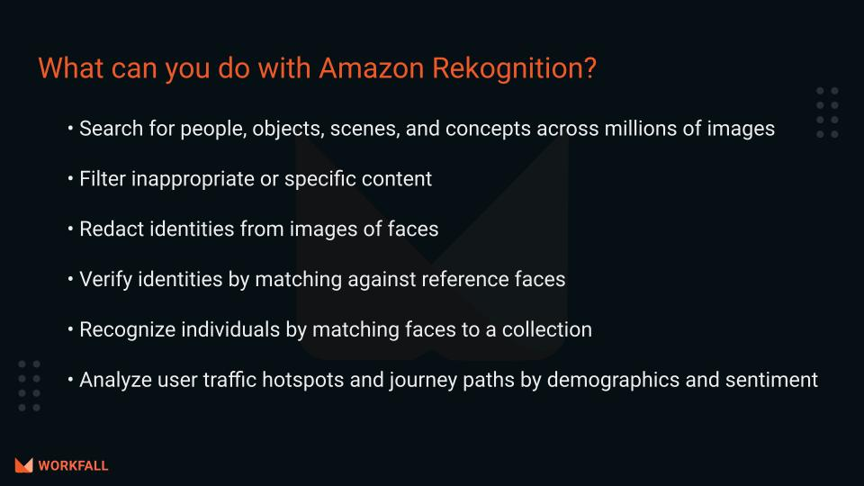

**Moderating content**

You can use Amazon Rekognition to detect content that is inappropriate, unwanted, or offensive. You can use Rekognition moderation APIs in social media, broadcast media, advertising, and e-commerce situations to create a safer user experience, provide brand safety assurances to advertisers, and comply with local and global regulations.

Today, many companies rely entirely on human moderators to review third-party or user-generated content, while others simply react to user complaints to take down offensive or inappropriate images, ads, or videos. However, human moderators alone cannot scale to meet these needs at sufficient quality or speed, which leads to a poor user experience, high costs to achieve scale, or even a loss of brand reputation. By using Rekognition for image and video moderation, human moderators can review a much smaller set of content, typically 1-5% of the total volume, already flagged by machine learning. This enables them to focus on more valuable activities and still achieve comprehensive moderation coverage at a fraction of their existing cost. To set up human workforces and perform human review tasks, you can use Amazon Augmented AI, which is already integrated with Rekognition.